|  | **BAHRIA UNIVERSITY, (Karachi Campus)**  *Department of Software Engineering*  **Assignment 1 - Fall 2022** |  |
| --- | --- | --- |

COURSE TITLE: **Computer Architecture & Logic Design** Course Code: **CEN-220**

Class: **BSE- III B** Shift: **Morning**

Course Instructor: **Dr.Sorath Hansrajani** Time Allowed:  **1 Weeks**

Submission Date: 10 NOV, 2022 Max. Marks: **5 Marks**

Name: **Muhammad Shoaib Akhter Qadri**

Enrollment No: **02-131212-009**

Regstration No: **79290**

**Question No. 1: Describe RAM and ROM:**

**Answer:**

**RAM:**

RAM stands for Random Access Memory. It is the internal memory of the CPU in the form of a hardware device located on the motherboard of a computer. It is designed to store data, programs, and results of a program when a computer is switched on. It is the read and write memory of a computer as we can write information to it as well as read from it.

Furthermore, RAM is a volatile memory as it can?t store data and instructions permanently. For example, when we switch on a computer, the instructions from the hard disk are stored in the RAM. These instructions include the operating system (OS) and other programs which are needed to run a computer. CPU uses these instructions to perform the tasks required to run the computer. This data is retained by the RAM as long as the computer is on, the moment you shut it down, the RAM loses the data. The reason for transferring the data to RAM is that it is easy and fast to read data from RAM as compared to reading it from the hard drive.

**ROM:**

ROM stands for read only memory. It is a non-volatile memory that stores information permanently, even when the power is turned off. Like RAM, it is also the primary memory of a computer. It is called read only memory as the programs and data stored in it can be read but cannot be written on it.

At the time of manufacturing, the manufacturer fills the ROM with programs that can?t be altered later. So, you cannot reprogram, rewrite, or erase its data after it is manufactured. However, in some types of ROM, you can modify the stored data. Some common examples of ROM include cartridge used in video game consoles, the data stored permanently on personal computers, and other electronic devices like smartphones, tablets, TV, AC, etc.

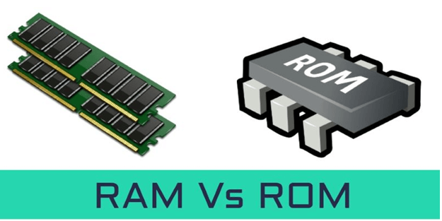

|  |  |
| --- | --- |
| **RAM** | **ROM** |
| **RAM** stands for Random Access Memory | **ROM** stands for read only memory |
| It is a temporary memory of the computer. | It is the permanent memory of the computer. |
| It is a read-write memory. The data can be written and read. | It is a read only memory. The data can only be read. |
| It is a volatile memory as it temporarily stores the files as long as the computer is on and working. | It is a non-volatile memory as it permanently stores the files even when the power is turned off, such as game cartridge and BIOS program stored in the memory of a computer, etc. |
| The storage capacity ranges from 1 to 256 GB. | Its storage capacity ranges from 4 to 8 MB. |
| Data stored in RAM can be retrieved and altered. | We can only read the data stored in ROM. It cannot be altered. |
| It is faster than ROM as it is a high-speed memory. | It is slower than the RAM. |
| The stored data is easy to access | The stored data is not as easy to access as it is in ROM. |
| Data stored in RAM can be retrieved and altered. | We can only read the data stored in ROM. It cannot be altered. |
| It is costlier than ROM | It is cheaper than RAM. |
| **Types:**  DRAM (Dynamic Random Access Memory), SRAM (Static Random Access Memory). | **Types**  PROM (programmable read-only memory), EPROM (erasable programmable read-only memory), EEPROM( electrically erasable programmable ROM), Mask ROM. |
| **Examples:**  It is used as CPU Cache, Primary Memory in a computer. | **Examples**  It is used as Firmware by micro-controllers. |

**Question No. 2: Define DRAM and SRAM and state their differences.**

**Answer:**

**DRAM:**

**Dynamic Random Access Memory (DRAM):** Data is stored in capacitors. Capacitors that store data in DRAM gradually discharge energy, no energy means the data has been lost. So, a periodic refresh of power is required in order to function. DRAM is called dynamic as constant change or action(change is continuously happening) i.e. refreshing is needed to keep the data intact. It is used to implement main memory.

***Advantage:****Low costs of manufacturing and greater memory capacities.****Disadvantage:****Slow access speed and high power consumption.*

**SRAM:**

**Static Random Access Memory (SRAM):** Data is stored in transistors and requires a constant power flow. Because of the continuous power, SRAM doesn’t need to be refreshed to remember the data being stored. SRAM is called static as no change or action i.e. refreshing is not needed to keep the data intact. It is used in cache memories.

***Advantage:****Low power consumption and faster access speeds.****Disadvantage:****Fewer memory capacities and high costs of manufacturing.*

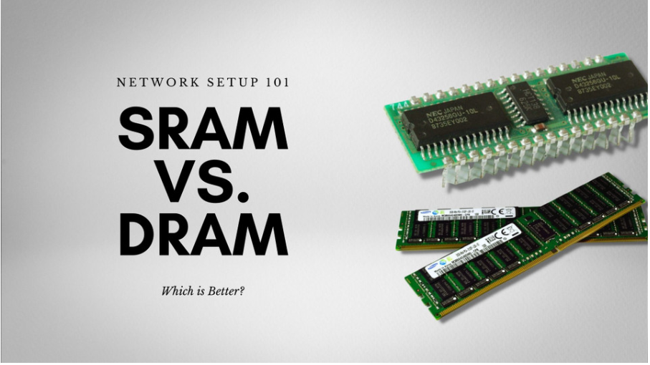

|  |  |
| --- | --- |
| **DRAM** | S**ROM** |
| DRAM is dynamic RAM. | SRAM is Static RAM. |
| DRAM can do byte-level writing and multiple-byte-level reading. | SRAM can do byte-level read and write. |
| DRAM needs refreshing as it operates on the principle of charging the capacitor. | There is no need for refreshing in SRAM as it operates on the principle of switching the current. |
| It is less expensive. | SRAM is more expensive than DRAM. |
| DRAM is slower. | SRAM is faster. |
| DRAM is used in the main memory. | SRAM is used in the cache memory. |
| The structure of the DRAM module needs a transistor and a capacitor for storing every bit of data. | The structure of SRAM needs a lot of transistors. |
| DRAM requires less power than SRAM inactive state. | SRAM consumes less power than DRAM in sleep mode. |

**Question No. 3: Define and state the differences among PROM, EPROM and EEPROM.**

**Answer:**

**PROM:**

**Dynamic Random Access Memory (DRAM):** Data is stored in capacitors. Capacitors that store data in DRAM gradually discharge energy, no energy means the data has been lost. So, a periodic refresh of power is required in order to function. DRAM is called dynamic as constant change or action(change is continuously happening) i.e. refreshing is needed to keep the data intact. It is used to implement main memory.

***Advantage:****Low costs of manufacturing and greater memory capacities.****Disadvantage:****Slow access speed and high power consumption.*

**EPROM:**

**Static Random Access Memory (SRAM):** Data is stored in transistors and requires a constant power flow. Because of the continuous power, SRAM doesn’t need to be refreshed to remember the data being stored. SRAM is called static as no change or action i.e. refreshing is not needed to keep the data intact. It is used in cache memories.

***Advantage:****Low power consumption and faster access speeds.****Disadvantage:****Fewer memory capacities and high costs of manufacturing.*

**EEPROM:**



|  |  |  |
| --- | --- | --- |
| **PROM:** | **EPROM:** | **EEPROM:** |
|  |  |  |
|  |  |  |
|  |  |  |
|  |  |  |
|  |  |  |
|  |  |  |
|  |  |  |
|  |  |  |
|  |  |  |
|  |  |  |
|  |  |  |
|  |  |  |
|  |  |  |